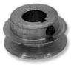 | REPLACEMENT PARTS  Steel V-Belt Pulleys (For 1/2" Belts)

Pulleys
Picture | OD | BORE | KEYWAY | ORDER
 | 2" | 3/4" | 3/16" | Part# 275313  Our Price: $9.09  Qty:
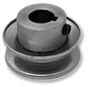 | 2" | 5/8" | 3/16" | Part# 275339  Our Price: $6.30  Qty:
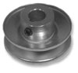 | 2 1/2" | 5/8" | 3/16" | Part# 275370  Our Price: $6.30  Qty:
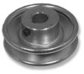 | 3" | 5/8" | 3/16" | Part# 275396  Our Price: $7.88  Qty:
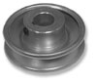 | 3" | 3/4" | 3/16" | Part# 275404  Our Price: $7.94  Qty:
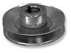 | 3 1/2" | 3/4" | 3/16" | Part# 275487  Our Price: $8.15  Qty:
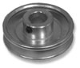 | 3 1/2" | 7/8" | 3/16" | Part# 275495  Our Price: $7.96  Qty:
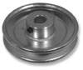 | 4" | 5/8" | 3/16" | Part# 275529  Our Price: $9.13  Qty:
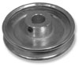 | 4" | 3/4" | 3/16" | Part# 275537  Our Price: $9.50  Qty:

Comments: Gear down 2:3

